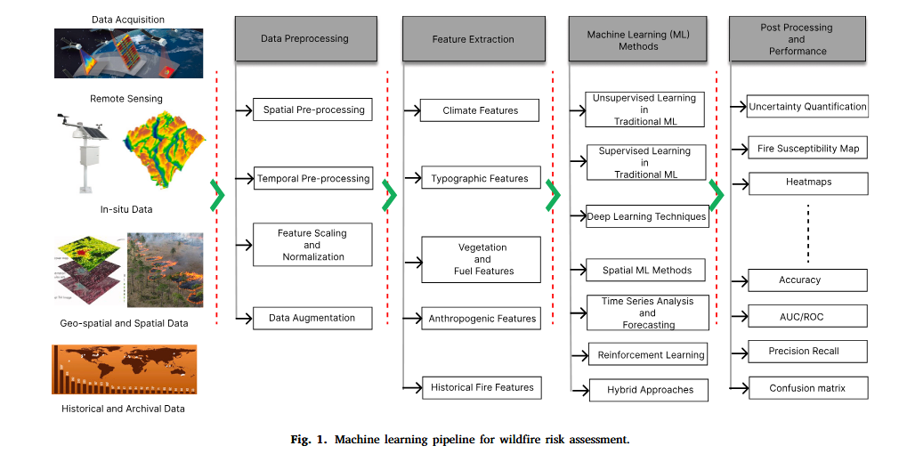
Fig. 1. Machine learning pipeline for wildfire risk assessment. (p4)

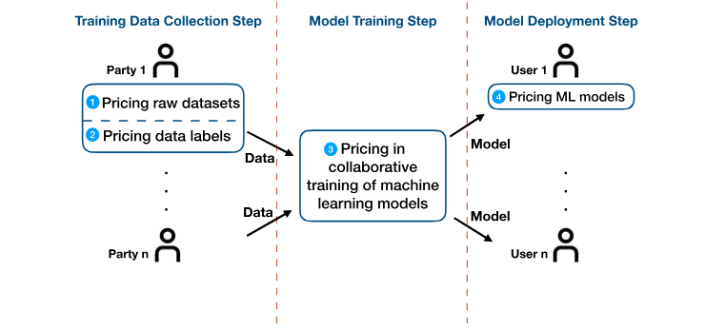
Fig. 1 Steps and pricing tasks in machine learning pipelines. (p3 or 149)
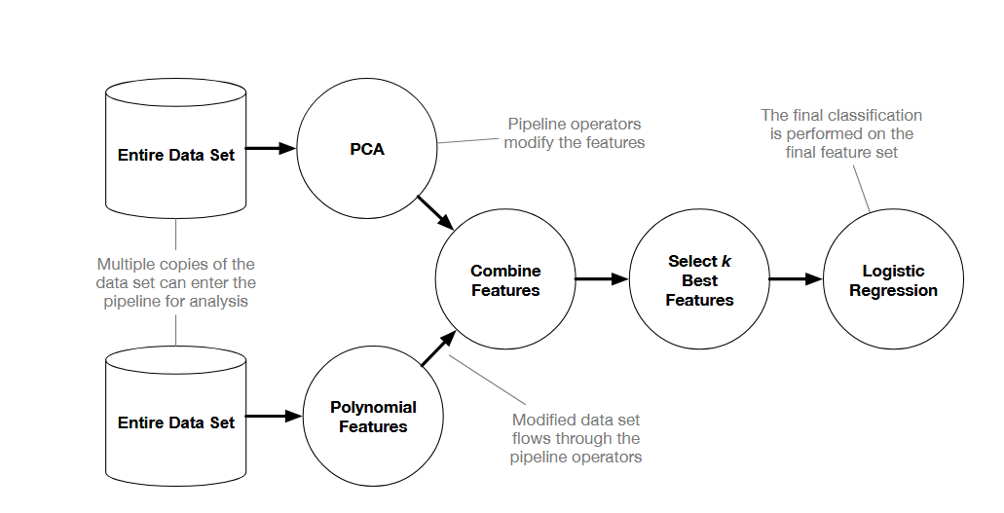
Figure 1: An example tree-based pipeline from TPOT. Each circle corresponds to a machine learning operator, and the arrows indicate the direction of the data flow. (p3 or 68)
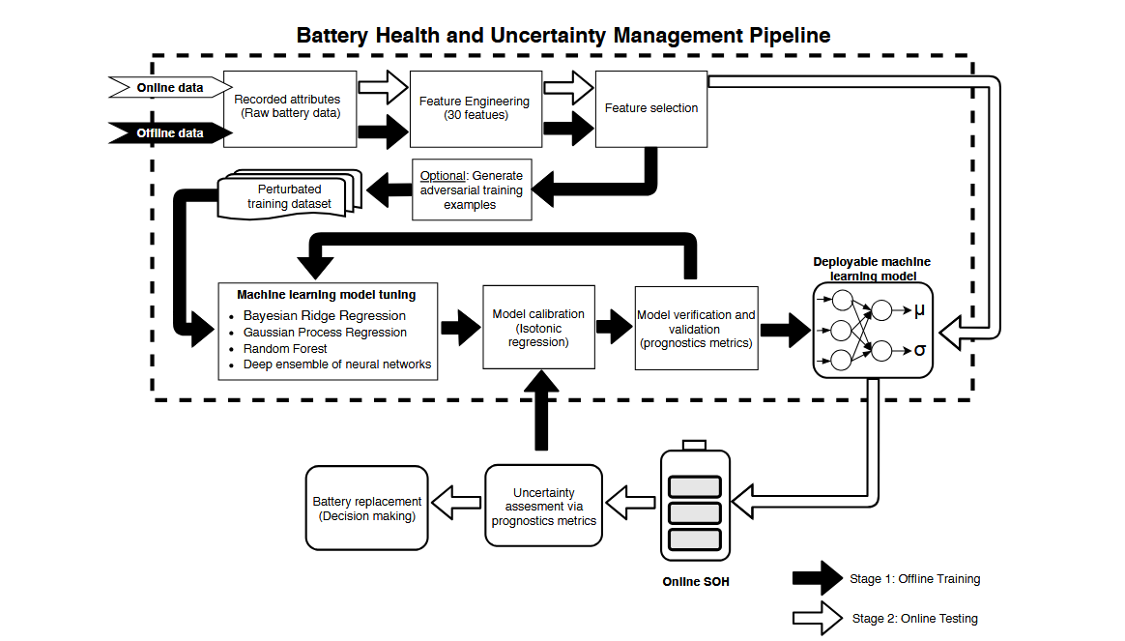
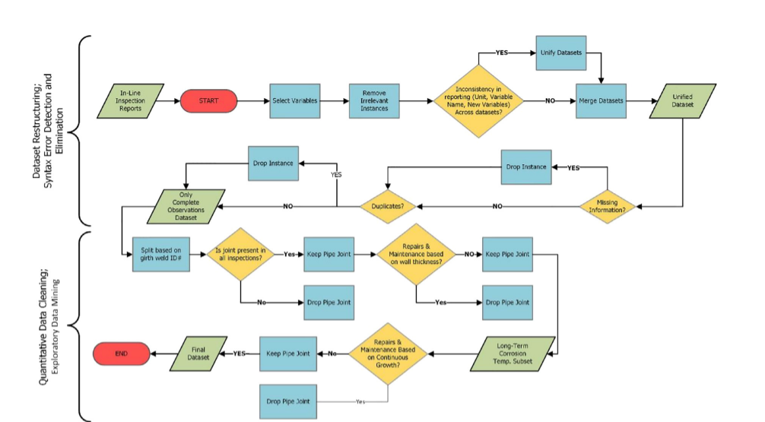
Figure 6: BHUMP flowchart. (p18)

Fig. 6. Flowchart of cleaning datasets prior to being used for modeling (Khan et al., 2021). (p10 or 1322)
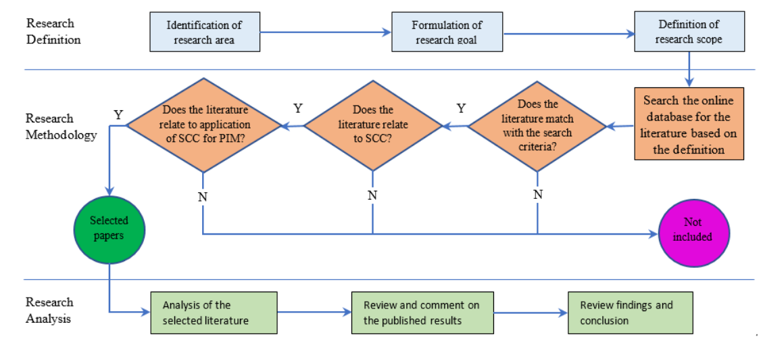
Figure 2. Methodological framework for research. (p5)
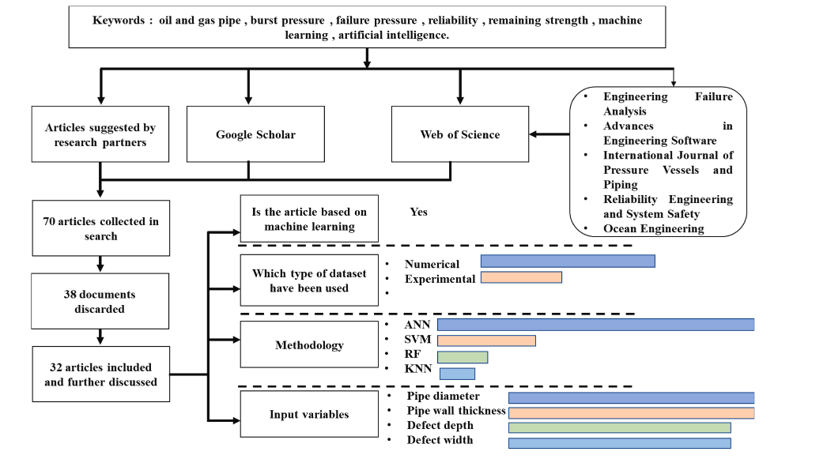
Fig. 4. Methodology followed to achieve systematic literature review. (p5)
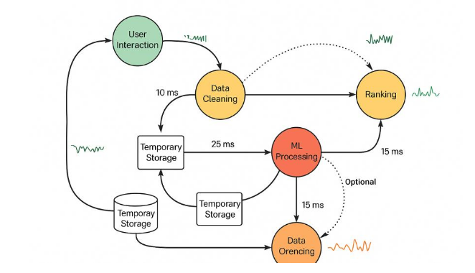
Figure 3. Data Flow for Collection, Analysis, and Recommendation Generation.(p6)
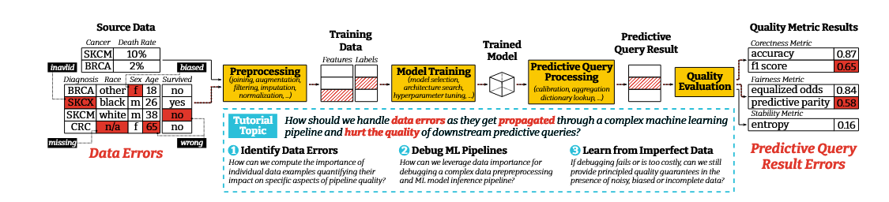
Figure 1: Data errors are often the root cause of many quality issues in modern ML pipelines. Handling such errors as theytraverse complex pipeline steps is a key challenge for practitioners.This tutorial covers some significant recent developments, presents novel tools, and explores opportunities for future work in this space.
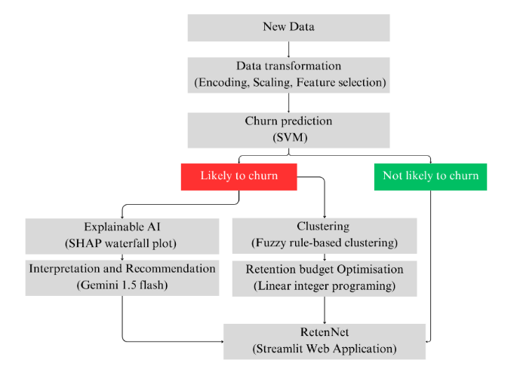
Figure 3. Deployed RetenNet Architecture
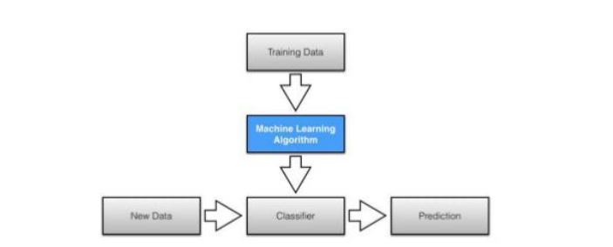

Figure 1: Supervised learning process [18]
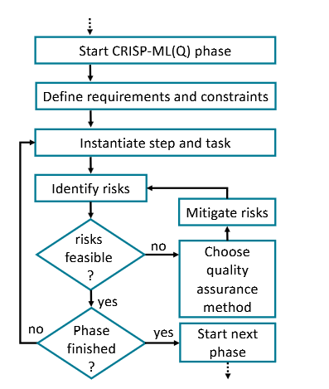
Figure 2. Illustration of the CRISP-ML(Q) approach for QA.

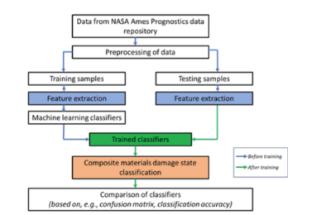

Figure 4 : Framework for classification of damage levels
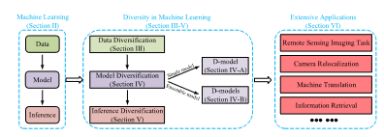

FIGURE 1. The basic framework of this paper.
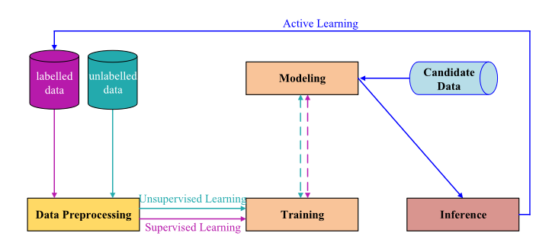

FIGURE 2. Flowchart for training process of general machine learning (including the active learning, supervised learning and unsupervised learning).
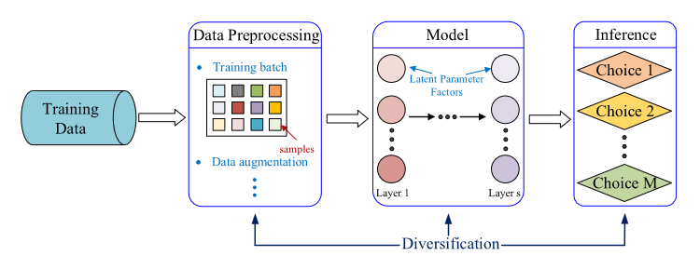

FIGURE 3. Flowchart of a special form of supervised machine learning with single model.
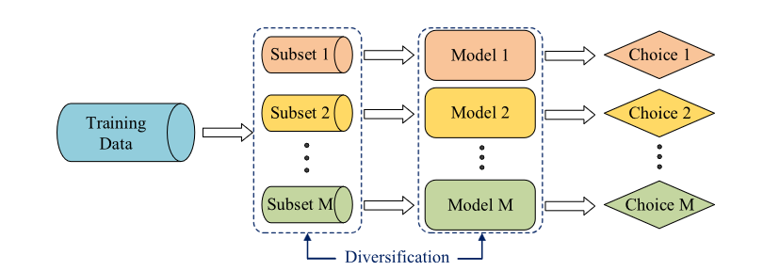

FIGURE 4. Flowchart of supervised machine learning with multiple parallel models

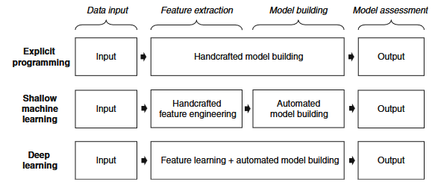

Fig. 2 Process of analytical model building (inspired byGoodfellow et al. 2016, p. 10)
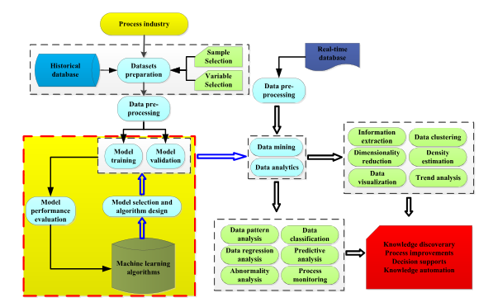
FIGURE 1. Overview of the data mining and analytics methodology
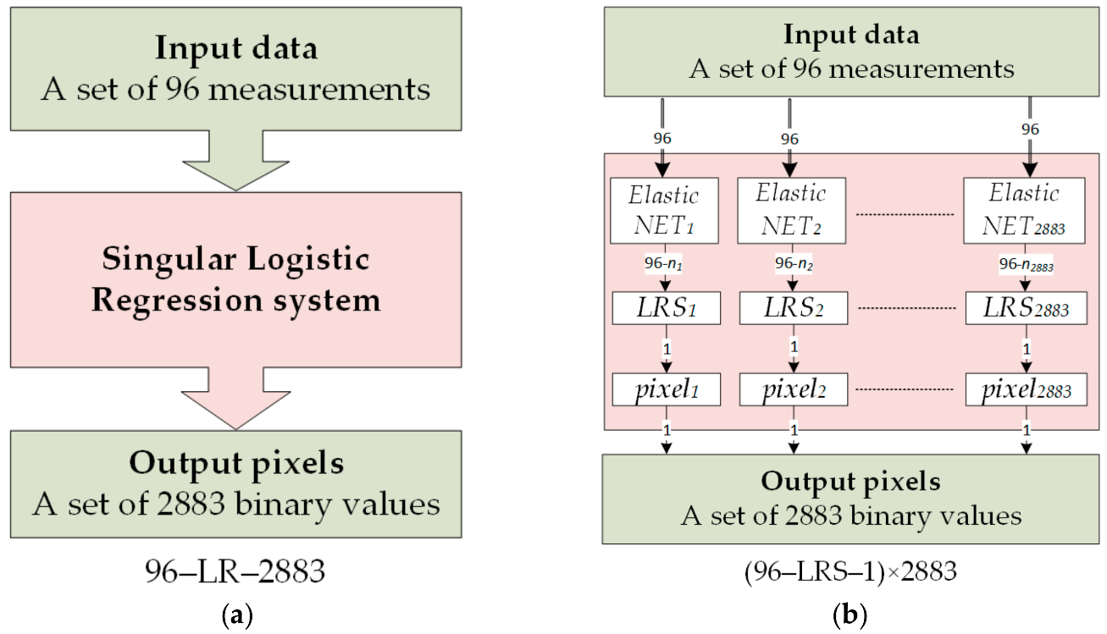
Figure 2. Comparison of algorithms for: (a)—single logistic regression unit, (b)—multiple LRS.
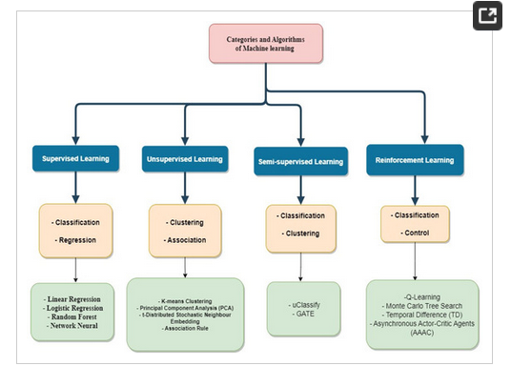

Figure 1. Different machine learning categories and algorithms [14].
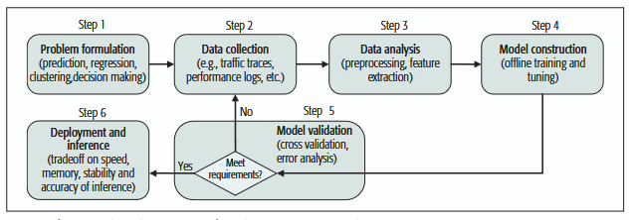

FIGURE 1. The typical workflow of machine learning for networking.
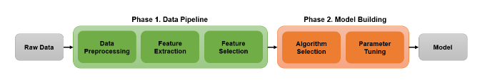

Figure 1: Typical machine learning workflow
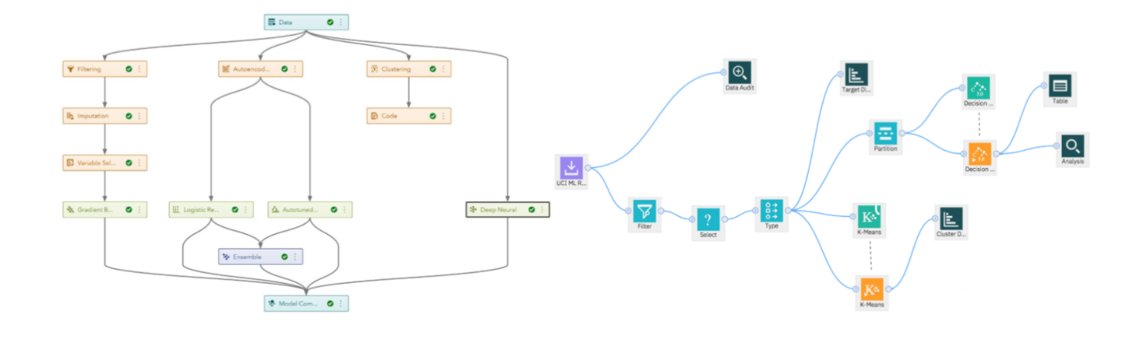Figure 2: Example of real-life pipelines designed with SAS (left) and IBM Watson Studio (right).
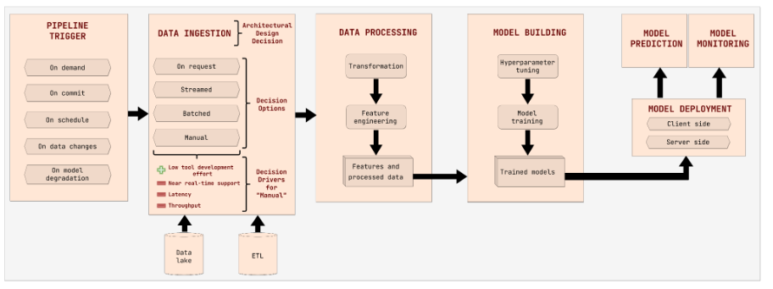Figure 1. A simplified ML pipeline.
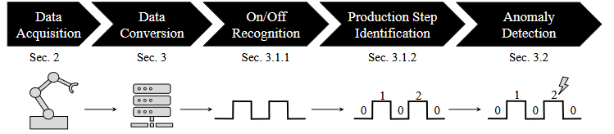
Figure 3: The simplified overall workflow.

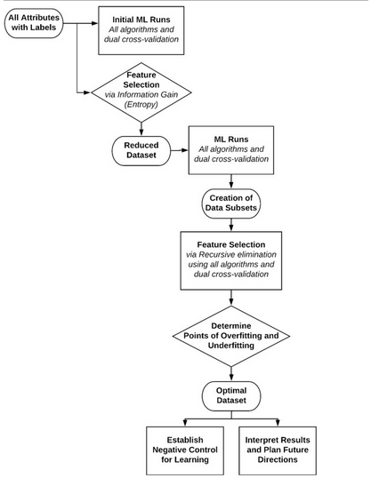

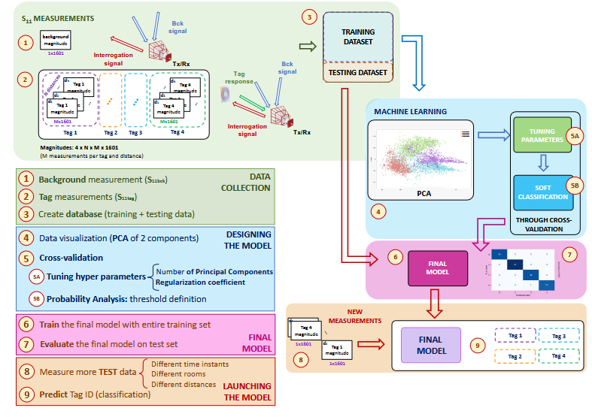
Fig. 2. Workflow scheme of a supervised machine learning (ML) analysis

Fig. 5. Proposed machine learning workflow for chipless tag identification.

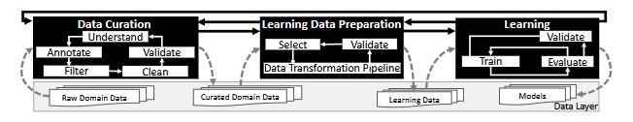
Fig. 2: The Lifecycle of Scientific ML
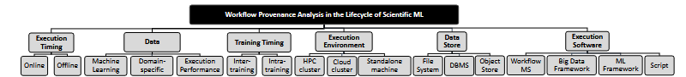
Fig. 3: A taxonomy for workflow provenance analysis of the lifecycle of scientific ML.
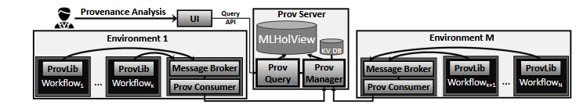Fig. 6: Reference system architecture to manage workflow provenance in the lifecycle of scientific ML.
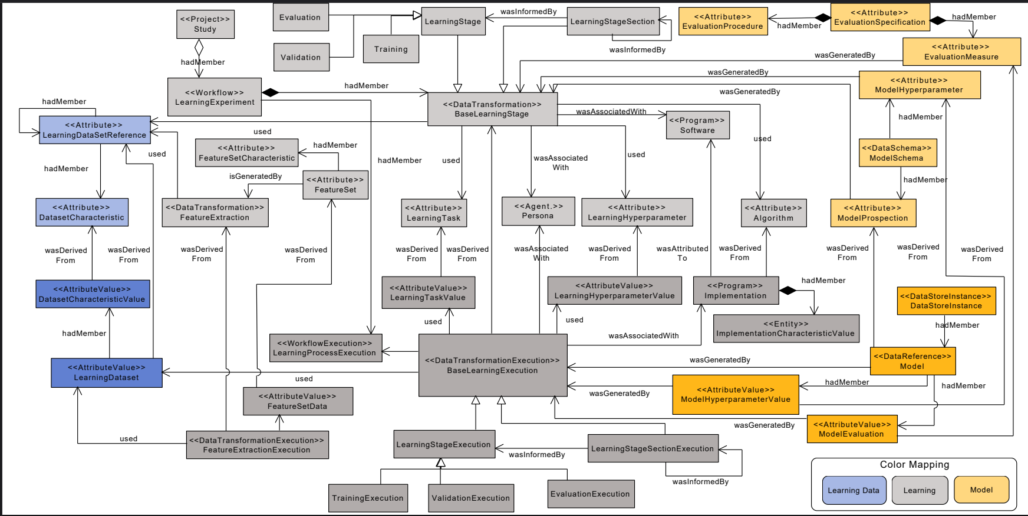
Fig. 7: PROV-ML: a W3C PROV- and W3C ML Schema-compliant provenance data representation for scientific ML.
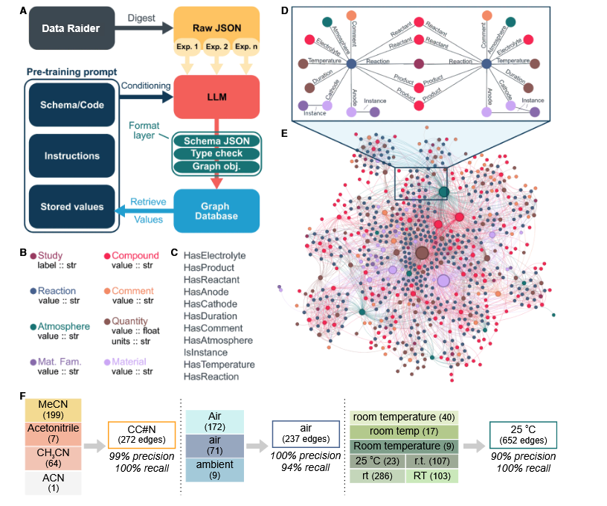
Figure 4. Key features of KGWizard
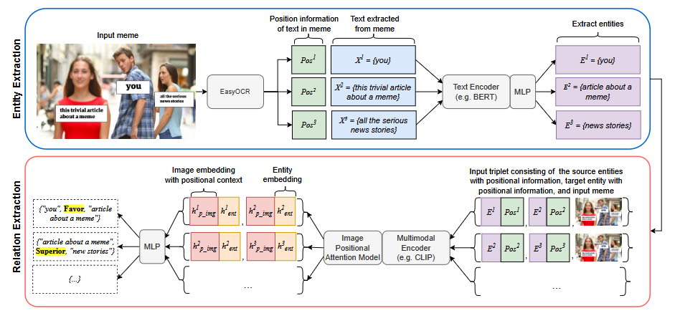
Fig. 3. Architecture of MERF pipeline

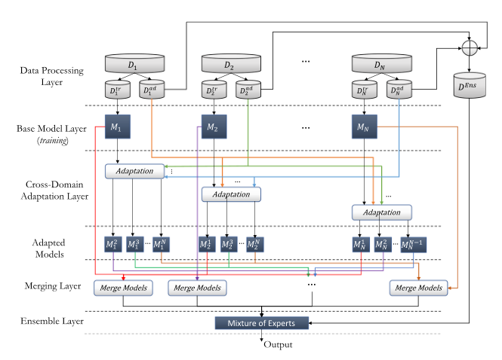

Fig. 1 MERMAID solution approach
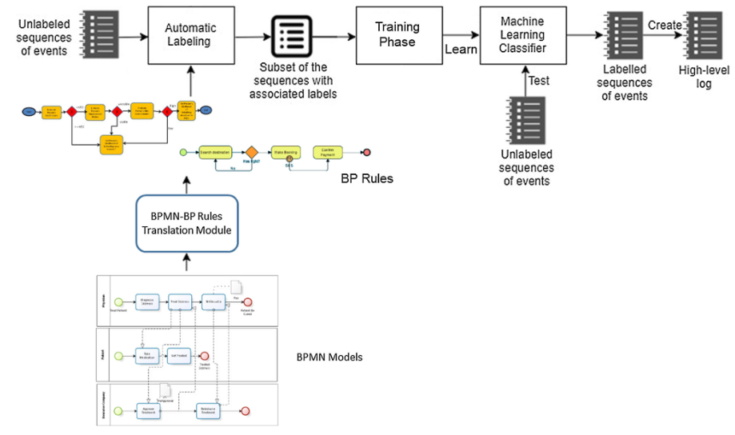

Fig. 1 Overview of the proposed framework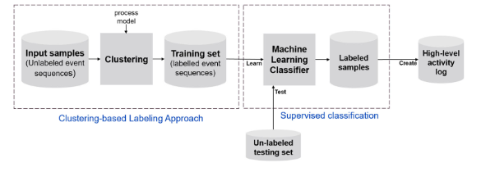
Fiig. 5 Overview of the proposed framework when implementing automatic labeling based on clustering approaches

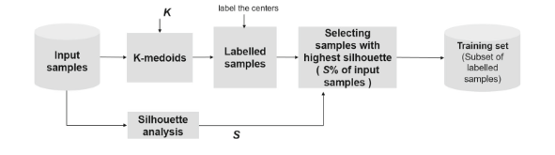

Fig. 6 Clustering-based labeling approach being K the number of high-level activities from the high-level process model, and S the percentage of samples with highest silhouette

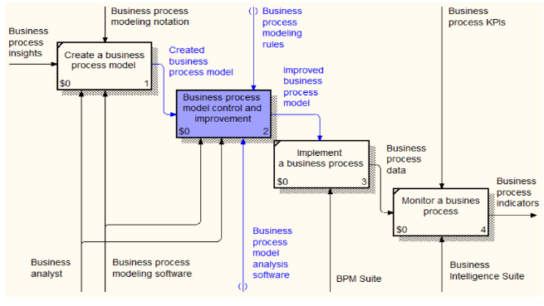
Fig. 6. The proposed improvement of the BPM lifecycle
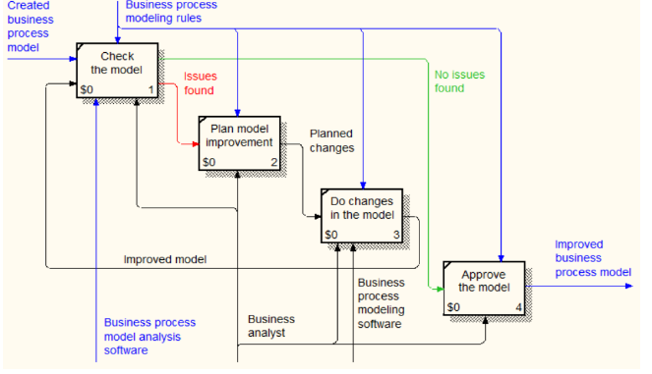
Fig. 7. The decomposition diagram of the business process model validation and improvement stage

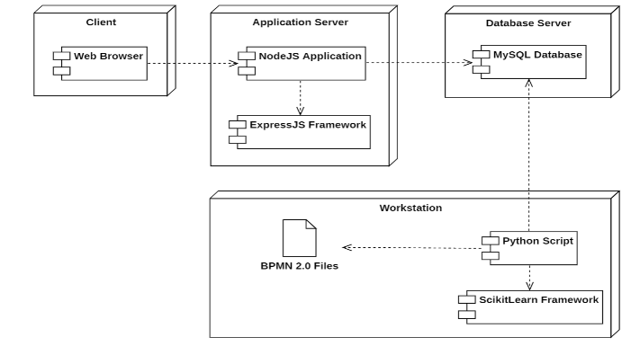
Fig. 8. The deployment diagram of the developed software components
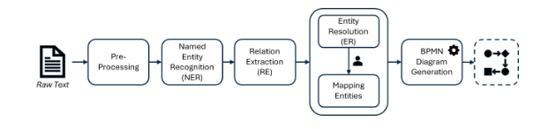
Fig. 1: General Extraction pipeline

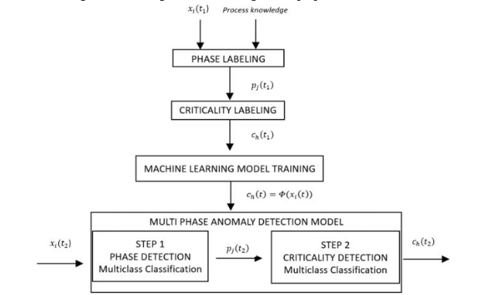
Figure 4. Methodology logical scheme

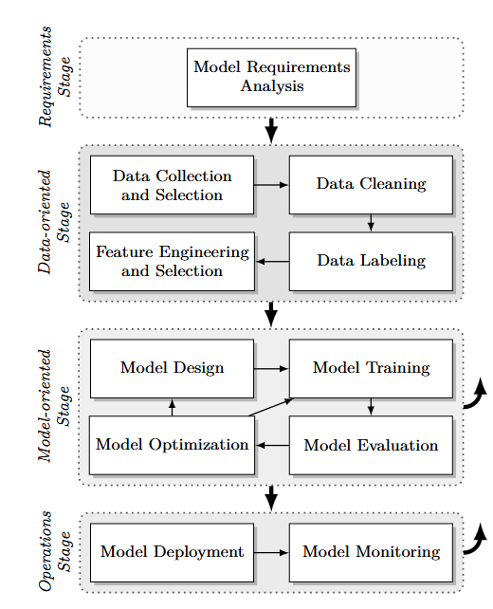
Figure 1: Typical ML lifecycle.

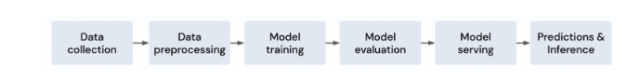
Figure 3. A high-level overview of the machine learning life cycle.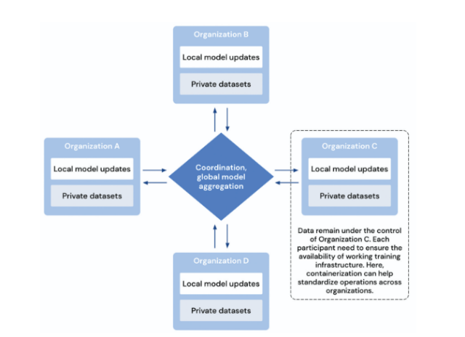
Figure 6. Federated Learning.
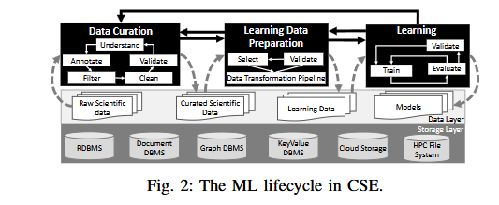
Fig. 2: The ML lifecycle in CSE.
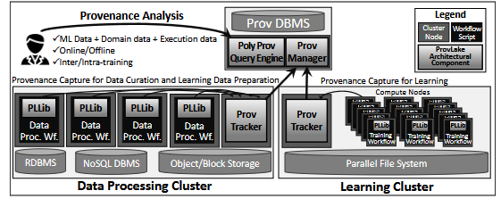
Fig. 4: ProvLake architecture on an exemplary deployment on two clusters: for data preprocessing and for learning.

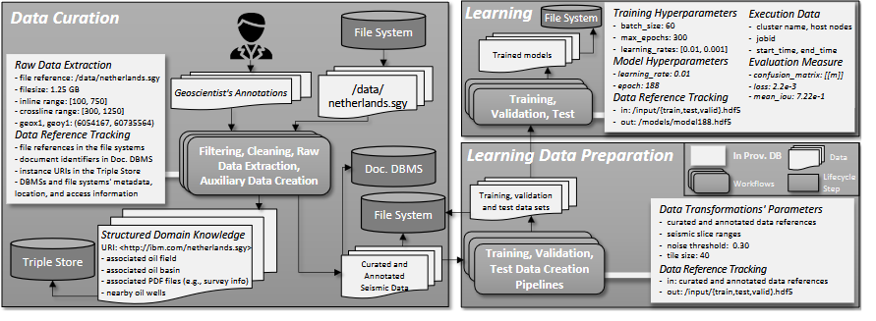
Fig. 7: Provenance data tracking in an O&G use case for the ML lifecycle in CSE.

